**A Real-Time Research Project Report**

on

# IoT Based Home Automation System-ESP8266

*submitted in partial fulfillment of the requirements for the award of the degree of*

## BACHELOR OF TECHNOLOGY

## in

## ELECTRICAL AND ELECTRONICS ENGINEERING

## By

**Ms. Name of the student Roll no.**

**Ms. Sripriya Rathod 22WH1A0205**

**Ms. Janani Nagarajan 22WH1A0218**

**Ms. Jessi Elina 22WH1A0215**

**Ms. Srigiri Advaitha 22WH1A0209**

Under the Guidance of

**Mrs. B Sujatha**

Associate Professor, EEE



# Department of Electrical and Electronics Engineering

# BVRIT HYDERABAD College of Engineering for Women

**July 2024**

**DECLARATION**

We hereby declare that the work described in this report, entitled **“IoT Based Home Automation-ESP8266”** which is being submitted by us in partial fulfillment for the award of the degree of **Bachelor of Technology** in the department of **Electrical and Electronics Engineering** at **BVRIT HYDERABAD College of Engineering for Women,** affiliated to **Jawaharlal Nehru Technological University Hyderabad**, Kukatpally, Hyderabad – 500085 is the result of original work carried out by us under the guidance of **Mrs.** **B. Sujatha, Associate Professor**, **EEE.**

This work has not been submitted for any Degree / Diploma of this or any other institute/university to the best of our knowledge and belief.

**Sri Priya Rathod**

**22WH1A0205**

**Janani Nagarajan**

**22WH1A0218**

**Jessi Elina**

**22WH1A0215**

**Srigiri Advaitha**

**22WH1A0209**

# Department of Electrical and Electronics Engineering

# BVRIT HYDERABAD College of Engineering for Women

**(Approved by AICTE, New Delhi and Affiliated to JNTUH, Hyderabad) Accredited by NBA and NAAC with A Grade**

**Bachupally, Hyderabad – 500090**



**Certificate**

This is to certify that an Industry Oriented Mini Project Work report, entitled “**IoT Based Home Automation -ESP8266**” is a bonafide work carried out by **Ms. Sripriya Rathod,**

**Ms. Janani Nagarajan, Ms. Jessi Elina, Ms. Srigiri Advaitha** in the partial fulfillment for the award of B.Tech. degree in Electrical and Electrical Engineering**, BVRIT HYDERABAD College of Engineering for Women, Bachupally, Hyderabad**, affiliated to **Jawaharlal Nehru Technological University Hyderabad**, Kukatpally, Hyderabad – 500085 under my guidance and supervision.

The results embodied in the project work have not been submitted to any other University or Institute for the award of any degree or diploma.

Supervisor Head of the Department

# Mrs. B Sujatha Dr. B. SRINIVASA RAO

**Associate Professor, EEE Professor & HOD, EEE**

# ACKNOWLEDGEMENT

The satisfaction that accompanies in successful completion of the task would be incomplete without the mention of the people who made it possible.

We express our gratitude towards our honorable Principal, **Dr. K V N Sunitha** and the **Management** for providing all the facilities.

Our sincere thanks and gratitude to our Head of the Department Dr. **B. Srinivasa Rao, Professor,** Department of Electrical and Electronics Engineering**, BVRIT HYDERABAD College of Engineering for Women** for all the timely support and valuable suggestions during the period of our project.

We are extremely thankful and indebted to our guide, **Mrs. B Sujatha, Associate Professor,** Department of Electrical and Electronics Engineering**, BVRIT HYDERABAD College of Engineering for Women** for her constant guidance, encouragement, and moral support throughout the project. I would like to extend my sincere thanks to the faculty coordinator **Dr. Prasanta Kumar Jena, Assistant Professor, EEE** department and review committee members for their valuable comments and suggestions.

We also thank all the **Faculty** and **Non-teaching staff members** of the **Electrical and Electronics Engineering** department, who supported us directly or indirectly in successful completion of this project work.

Finally, we thank all our **Friends** and **Family members** for their continuous support and help.

**R. Sripriya (2WH1A0205)**

**N. Janani (22WH1A0218)**

**S. Jessi Elina (22WH1A0215)**

**S. Advaitha (22WH1A0209)**

**CONTENTS**

|  |  |  |
| --- | --- | --- |
| **S. No.** | **Topic** | **Page No.** |
|  | Abstract | i |
|  | List of Components | ii |
|  | List of Figures | iii |
| 1 | Introduction  1.1 Objective of the Project  1.2 Problem Statement | 1-2 |
| 2 | Literature Survey | 3 |
| 3 | Block Diagram | 4 |
| 4 | Component Description  4.1 ESP8266  4.2 Two channel Relay  4.3 Electric Bulb  4.4 Jumper wires  4.5 Bread board  4.6 5V Battery | 5-11 |
| 5 | Software Description  5.1 Arduino ide  5.2 Blynk IoT | 12 |
| 6 | Methodology | 14 |
| 7 | Hardware Model Development | 16 |
| 8 | Conclusion | 17 |
| 9 | Future Scope | 18 |
| 10 | References | 19 |
| 11 | Appendix | 20 |

**ABSTRACT**

The aim of the project is to build a home automation system with the ESP8266 Wi-Fi module. The system will give users an accessible, flexible, and scalable way for controlling appliances in the home. Users can efficiently handle their home environment via a web interface or smartphone application to control the system remotely. The ESP8266 microcontroller and two-channel relays are the essential components of the system that allow for the real-time monitoring and control of appliances, as well as security systems. To enhance user interaction, the system explores the integration of voice control and artificial intelligence. It minimizes basic household operations and enhances the home's functionality. The hardware components are ESP8266 microcontroller, two-channel relay, electric bulbs and fan. The Software requirements are Arduino IDE for programming, Blynk IoT application for remote control and monitoring.

i

**LIST OF COMPONENTS**

|  |  |
| --- | --- |
| **S.no** | **Name of the Components** |
| 1. | ESP8266 Microcontroller |
| 2. | Two channel Relay |
| 3. | Electric Bulb |
| 4. | Jumper wires |
| 5. | 5V Battery |

ii

**LIST OF FIGURES**

|  |  |
| --- | --- |
| **S. No** | **Figures** |
| 1 | Home Automation Using mobile |
| 2 | Block Diagram of IoT based Home Automation-ESP8266 |
| 3 | ESP8266 |
| 4 | Two Channel Relays |
| 5 | Electric Bulb |
| 6 | Jumper Wires |
| 7 | Bread Board |
| 8 | 5V Battery |
| 9 | Arduino IDE |
| 10 | Blynk IoT Application |
| 11 | Methodology |
| 12 | Hardware Model Development |

iii

1. **INTRODUCTION**

Home Automation is a system that allows users to control various appliances of varying kinds and also makes controlling of home appliances easier and saves energy. Home Automation refers to the use of smart technology to control and automate household appliances and systems, enhancing convenience, comfort and energy efficiency.The growing demand for smart home technology reflects the modern necessity for enhanced convenience, security, and energy efficiency in household management. Traditional home systems, which require manual control and monitoring, are often inefficient, inconvenient, and prone to human error. This has led to an increasing interest in the Internet of Things (IoT), which connects everyday devices to the internet, allowing for remote control and monitoring. IoT-based home automation improves convenience by enabling homeowners to manage their home environments from anywhere, enhances security through real-time monitoring and alerts, and optimizes energy usage by automating and scheduling device operations. The need for cost-effective solutions is paramount, making advanced home automation accessible to a broader audience.

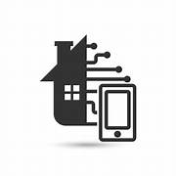

**Figure 1: Home Automation using mobile**

The ESP8266, a low-cost Wi-Fi microchip with microcontroller capabilities, connects to the home Wi-Fi network and interacts with sensors that detect physical changes and actuators that take action (such as turning on lights or adjusting thermostats). The ESP8266 receives data and communicates via Wi-Fi. It may be programmed using environments such as the Arduino IDE.Sensor data can be sent to cloud platform Blynk, allowing for remote monitoring and control the Household appliances. This comprehensive setup provides a smart, efficient, and secure home environment, controllable from anywhere in the world.

**1.1: OBJECTIVE OF THE PROJECT:**

1. Develop an IoT based home automation which helps in controlling the household appliances efficiently.
2. It enhances user interaction through user friendly interfaces such as switching controls in mobile app.

**1.2: PROBLEM STATEMENT:**

To develop an IoT-based home automation system using the ESP8266 microcontroller, enabling users to remotely control and monitor home devices through a smartphone app or web interface. The system should facilitate seamless integration of sensors and actuators, support automation rules and schedules. This will improve home convenience, energy efficiency, and security while being affordable and accessible for a wide range of users.

1. **LITERATURE SURVEY**

The concept of IoT-based home automation has gained significant attention in recent years, with various researchers exploring different aspects and technologies to enhance the functionality, efficiency, and security of smart homes. This literature review synthesizes findings from several key papers, providing an overview of methodologies, technologies, and innovations in the field of IoT-based home automation systems using the ESP8266.[1] Their work emphasizes the importance of remote monitoring and control of home appliances, which is achieved through the integration of actuators with a central controller, in this case, the ESP8266. The system is designed to enhance convenience and energy efficiency by allowing users to monitor and control devices via a web interface or a mobile application. The authors highlight the ease of implementation and cost-effectiveness of using the ESP8266, making it a popular choice for home automation projects.[2] An IoT-based smart home automation system that focuses on enhancing the user experience through seamless integration of various smart devices. The system employs the ESP8266 for wireless communication between devices and the central hub, ensuring real-time data exchange and control. The authors emphasize the importance of user-friendly interfaces, both web-based and mobile, to facilitate easy interaction with the system. They also discuss the scalability of the system, which allows for the addition of new devices and functionalities as needed.[3] A comprehensive literature review of IoT-based home automation systems, highlighting various technologies and methodologies used in the field. Their review discusses the advantages of using the ESP8266 for home automation due to its low cost, ease of programming, and reliable wireless communication capabilities.[4] IoT-based home automation system using an Android application for remote control and monitoring. Their system utilizes the ESP8266 as the core component for wireless communication, interfacing with various home appliances through relay modules. The Android application provides a user-friendly interface for controlling the appliances, making it accessible to users with minimal technical knowledge.[5] The implementation of an IoT-based home automation system, focusing on the integration of actuators to create a comprehensive smart home environment. Their system uses the ESP8266 for wireless communication, enabling real-time monitoring and control of devices.

1. **BLOCK DIAGRAM**

# The IoT-based home automation system using the ESP8266 is structured around several key components that work together to provide seamless control and monitoring of home appliances. At the core of the system is the ESP8266 microcontroller, which interfaces with various actuators. Actuators like relays, lights, fans, and other appliances are controlled by the ESP8266. The system connects to the internet via a Wi-Fi router, enabling the ESP8266 to communicate with the Blynk Cloud, which acts as the central hub for data exchange and command processing. Users interact with the system through the Blynk mobile application on their smartphones, providing a user-friendly interface for remote control and real-time monitoring of connected devices. The Blynk Cloud facilitates this interaction by receiving commands from the mobile app and sending them to the ESP8266, which then activates the appropriate sensors and actuators. This setup allows for efficient and convenient home automation, leveraging the ESP8266’s robust wireless communication capabilities and the versatility of the Blynk platform to enhance user experience and system functionality.

# 

# Figure 2: Block Diagram of IoT based Home Automation-ESP8266

# 4. COMPONENTS DESCRIPTION

**COMPONENTS DESCRIPTION**

➢ ESP8266

➢ Two channel Relay

➢ Electric Bulb

➢ Jumper Wires

➢ Bread board

➢ 5V Battery

**4.1 ESP8266 MICROCONTROLLER**

The ESP8266 is a highly versatile and cost-effective Wi-Fi microchip developed by Espressif Systems. It features a full TCP/IP stack and integrates a powerful 32-bit microcontroller, making it well-suited for a diverse range of IoT applications. Despite its compact size and affordability, the ESP8266 is renowned for its reliable performance and ease of use, making it popular among hobbyists, developers, and professionals alike. It supports 802.11 b/g/n Wi-Fi standards, enabling devices to connect to wireless networks and communicate over the internet seamlessly. With its low power consumption design, the ESP8266 is suitable for battery-powered applications, extending its utility to portable and energy-efficient IoT devices. Equipped with multiple General-Purpose Input/Output (GPIO) pins, it allows interfacing with various sensors, actuators, and peripheral devices, enhancing its versatility in project implementations. The ESP8266 can be programmed using a variety of development environments such as the Arduino IDE, ESP-IDF, and NodeMCU, providing flexibility and accessibility to developers of different skill levels. Supported by a large and active community, the ESP8266 benefits from extensive resources, tutorials, and community support, facilitating rapid prototyping and development of IoT solutions across industries including home automation, industrial automation, wearable technology.

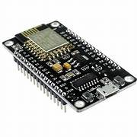

**Figure.3 ESP8266**

**4.2 Two channel Relay**

A two-channel relay is an electronic device used for switching and controlling two separate electrical circuits using a single control signal. Each channel of the relay operates independently, allowing for simultaneous control of different devices or circuits. Typically, a two-channel relay module consists of two relays, each with its own set of input terminals (often labeled as IN1 and IN2) for receiving control signals, and output terminals (such as COM, NO, and NC) for connecting to the circuits being controlled.

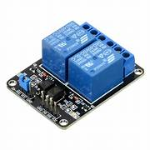

**Figure 4: Two channel Relay**

**4.3 Electric Bulb**

An electric bulb, also known simply as a light bulb or lamp, is a device that produces light through the conversion of electrical energy into radiant energy. The basic components of an electric bulb include a filament or LED (Light Emitting Diode), a glass bulb, and a base that connects to an electrical socket. Electric bulbs are used in various applications, including residential and commercial lighting, automotive lighting, decorative lighting, and specialized industrial applications. They provide illumination in homes, offices, streets, stadiums, vehicles, and more, contributing to safety, productivity, and comfort in everyday life.



**Figure.5 Electric bulb**

**4.4 Jumper Wires**

Jump wires, also known as jumper wires, are essential electrical wires with connectors or pins at both ends, eliminating the need for soldering. These wires, often stranded with solid tips, are commonly used to interconnect components on breadboards or prototype circuits. They facilitate internal connections within a circuit or linkages with external equipment without the use of solder. The individual jump wires are inserted into designated slots on a breadboard, circuit board header, or testing equipment. Jumper wires play a pivotal role in circuit prototyping, particularly with tools like breadboards. Their connector pins allow for easy and solder-free connections between two points, enabling swift circuit modifications.



**Figure.6 Jumper cables**

**4.5 Breadboard**

A breadboard is an essential tool in electronics prototyping, providing a platform for assembling temporary circuits without the need for soldering. It consists of a plastic board with a grid of holes arranged in rows and columns, each connected internally in a specific pattern. The holes are equipped with spring clips that securely hold component leads, facilitating easy insertion and removal of resistors, capacitors, integrated circuits, and other electronic components. The board also includes bus strips along the sides for distributing power (typically 5V and ground), enabling convenient connection to power sources and simplifying circuit design.

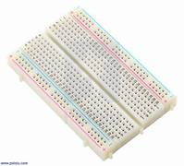

**Figure.7 Breadboard**

**4.6 5V Battery**

A 5V battery refers to a power source that provides a constant voltage of 5 volts. This type of battery is commonly used in various electronic devices and circuits that require low voltage power. It is often found in USB-powered devices, small electronics, and microcontroller projects such as those using Arduino or Raspberry Pi. The 5V battery can come in different forms, including rechargeable lithium-ion cells, standard AA batteries arranged to provide 5V, or dedicated 5V battery packs designed for specific applications. Its compact size and reliable voltage output make it a versatile choice for many portable and low-power electronics.

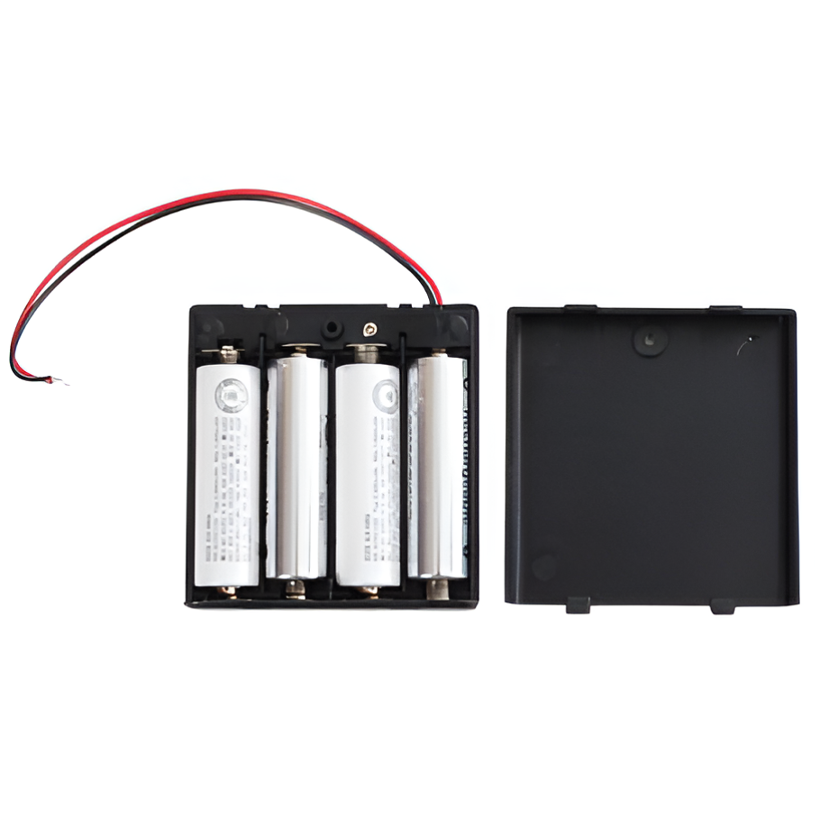

**Figure.8 5V Battery**

## 5. SOFTWARE DESCRIPTION

**5.1 ARDUINO IDE**

Writing and uploading code to the Arduino boards is done via the open-source Arduino IDE software. The IDE programmed works with a variety of operating systems, including Linux, Mac OS X, and Windows. The programming languages C and C++ are supported by it. IDE refers to the Integrated Development Environment in this context. Sketching is a common term used to describe programmer or code written in the Arduino IDE. To upload the sketch created in the Arduino IDE programmed, we must connect the ESP32 board to the IDE. The drawing is stored under the ‘. ino’ extension. The two primary components of the IDE environment are the Editor and Compiler, the former of which is used to write the necessary code and the latter of which is used to compile and upload the code into the specified Arduino Module. An Arduino IDE is used to setup and manage the functionality that the various hardware components and the Arduino UNO give. The system's initial basic drawing from the start of our project is displayed here.

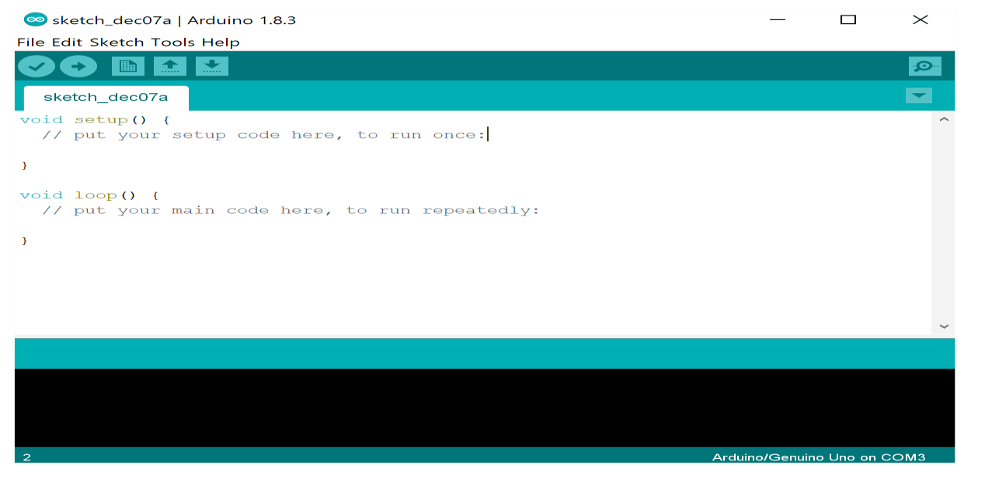

**Figure.9 Arduino IDE**

**5.2 Blynk IoT Application**

Blynk is an Internet of Things (IoT) platform designed for creating, developing, and deploying connected devices. It offers a comprehensive suite of tools, including a user-friendly mobile app for iOS and Android, which allows users to create custom interfaces to control devices and monitor data. The Blynk Cloud facilitates communication between devices and the app, managing data and device connections. The Blynk Library enables microcontrollers like Arduino, ESP8266, ESP32, Raspberry Pi, and others to connect to the Blynk Cloud, making it easy to send and receive data. The platform features various widgets for interactive interfaces, such as buttons, sliders, and graphs, powered by an energy system that acts as a virtual currency within the ecosystem. The Blynk. Console, a web-based interface, allows for device management, firmware updates, and data visualization. Blynk also supports notifications via push messages and email alerts, and offers integration with other platforms and services through APIs and webhooks. With secure communication ensured by SSL/TLS encryption, Blynk is a versatile and scalable solution for both DIY projects and commercial IoT applications.

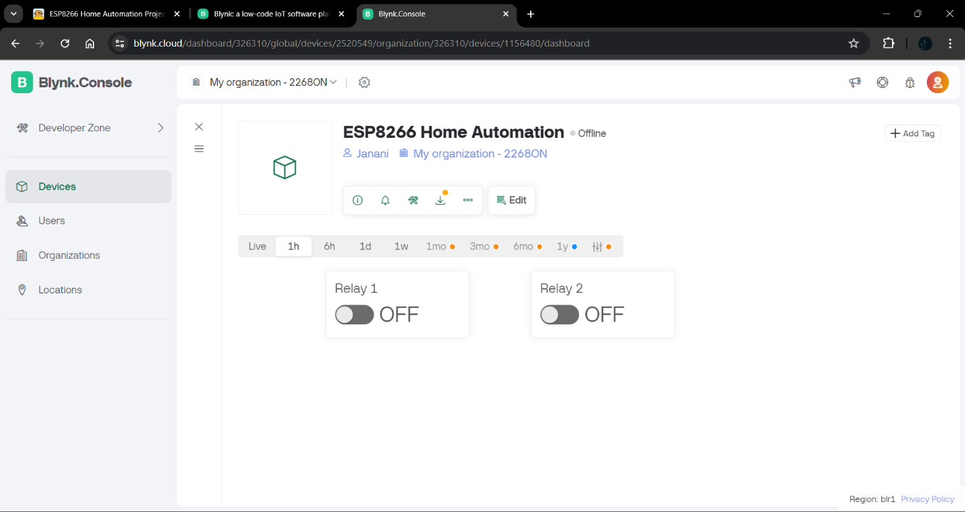

**Figure.10 Blynk IoT Interface**

**6. METHODOLOGY**

Implementing an IoT-based home automation system using the ESP8266 involves several steps, including setting up the hardware, programming the microcontroller, and integrating it with a cloud service like Blynk.

### Step 1: Define the Project Scope

Determine the devices and appliances required to be automated (e.g., lights, fans, temperature sensors) and the functionalities required (e.g., monitoring).

### Step 2: Gather Components

* **ESP8266**: A popular Wi-Fi module used for IoT projects.
* **Two channel Relay**: To control high-voltage appliances.
* **Power Supply**: Appropriate power source for the ESP8266 and connected components.
* **Breadboard and Jumper Wires**: For prototyping the circuit.

### Step 3: Set Up the Hardware

1. **Connect the ESP8266**:
   * Power the ESP8266 using a suitable power source (typically 3.3V).
   * Connect the GPIO pins of the ESP8266 to the relay modules and sensors.
   * Ensure proper grounding and connections to avoid hardware damage.
2. **Relay Module Connection**:
   * Connect the input pins of the relay module to the GPIO pins of the ESP8266.
   * Connect ground and power supply pins.

### Step 4: Program the ESP8266

1. **Install Arduino IDE**:
   * Download and install the Arduino IDE from the official website.
   * Install the ESP8266 board package via the Boards Manager.
2. **Install Libraries**:
   * Install necessary libraries, such as the Blynk library and any sensor-specific libraries.
3. **Write the Code**:
   * Initialize the Blynk library with your authentication token.
   * Define the pin configurations and sensor read/write logic.
   * Implement the logic to read sensor data and control appliances based on received commands.
4. **Upload the Code**:
   * Connect the ESP8266 to your computer via a USB-to-Serial adapter.
   * Upload the code to the ESP8266 using the Arduino IDE.

### Step 5: Configure Blynk

1. **Set Up the Mobile App**: Add widgets to your project to control and monitor your devices (e.g., buttons, sliders, graphs).
2. **Get Auth Token**: Obtain the authentication token from the Blynk app and include it in your ESP8266 code.

### Step 6: Test and Debug

1. **Test Connectivity**: Ensure the ESP8266 connects to your Wi-Fi network and communicates with the Blynk server.
2. **Test Functionality**: Verify that you can control appliances and read sensor data through the Blynk app
3. **Debug**: Troubleshoot any issues with hardware connections, code, or network connectivity.

### Step 7: Deployment

1. **Install at Home**: Install the system in your home, ensuring it is safely integrated with your home’s electrical system.

This methodology provides a structured approach to creating an IoT-based home automation system using the ESP8266, ensuring a comprehensive and secure setup.

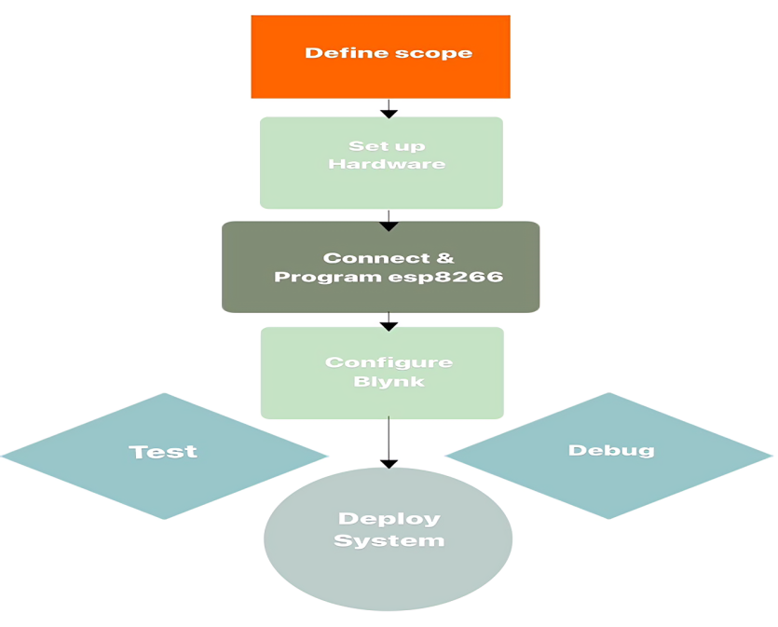

**Figure.11 Methodology**

**7. HARDWARE MODEL DEVELOPMENT**

The hardware implementation of an IoT-based home automation system involves connecting a two-relay switch to two lamps. Build a connection between the ESP8266 and the relay switch. After successfully connecting the ESP8266 to the relay switch, to write the code, access the Blynk web application setup page. Launch the Blynk web application, then choose the virtual pin data stream to create the on-and-off switches. Following this, we must configure the settings for the Arduino IDE and then insert the Blynk authentication token. Later on, insert your Wi-Fi credentials and choose the appropriate board and port. Following that, proceed to check and upload the code to the microcontroller. We must configure Blynk on our mobile device and control the on and off switches for both relays. Set up a connection between the ground (GND) and the negative terminal of the 5-volt battery power source, and link the VIN pin to the positive terminal of the 5V DC power source. Once you've arranged all these connections, check to see if the bulbs illuminate correctly after pressing the pushbutton. Inspect the switches on both the mobile and web dashboards.

## Figure.12 Hardware Model Developed

## 8. CONCLUSION

## The implementation of an IoT-based home automation system using the ESP8266 is a practical and effective way to enhance the convenience, efficiency, and security of a modern home. By leveraging the capabilities of the ESP8266, along with the versatile Blynk platform, users can remotely monitor and control various household appliances and systems through a user-friendly mobile app. This project not only demonstrates the potential of IoT technologies in everyday life but also provides a scalable solution that can be easily expanded to include additional devices and functionalities. The successful deployment and operation of this system highlight the importance of careful planning, thorough testing, and ongoing maintenance, ensuring a reliable and user-centric home automation experience.

## 9. FUTURE SCOPE

## 

The future scope of an IoT-based home automation system using the ESP8266 is vast and promising, with numerous potential advancements and applications. As technology continues to evolve, several key areas can be explored to enhance the system's functionality, efficiency, and user experience.

Future iterations of the home automation system could integrate seamlessly with other smart home ecosystems like Google Home, Amazon Alexa, and Apple HomeKit. This integration would allow users to control their devices using voice commands and benefit from advanced features offered by these platforms.

Integrating energy management systems can provide users with detailed insights into their energy consumption. Future systems could offer recommendations for reducing energy usage, integrating renewable energy sources, and managing power distribution effectively, contributing to a more sustainable lifestyle.

With the addition of health monitoring sensors, the home automation system could track vital signs, monitor environmental conditions like air quality, and provide alerts or recommendations to improve the well-being of the household members.

## 10. REFERENCES

1. Pavithra, D., & Balakrishnan, R. (2015, April). IoT based monitoring and control system for home automation. In *2015 global conference on communication technologies (GCCT)* (pp. 169-173). IEEE.
2. Stolojescu-Crisan, C., Crisan, C., & Butunoi, B. P. (2021). An IoT-based smart home automation system. *Sensors*, *21*(11), 3784.
3. Sivapriyan, R., Rao, K. M., & Harijyothi, M. (2020, January). Literature review of IoT based home automation system. In *2020 Fourth International Conference on Inventive Systems and Control (ICISC)* (pp. 101-105). IEEE.
4. Reddy, P. S. N., Reddy, K. T. K., Reddy, P. A. K., Ramaiah, G. K., & Kishor, S. N. (2016, October). An IoT based home automation using android application. In *2016 International conference on signal processing, communication, power and embedded system (SCOPES)* (pp. 285-290). IEEE.
5. Garg, S., Yadav, A., Jamloki, S., Sadana, A., & Tharani, K. (2020). IoT based home automation. *Journal of Information and Optimization Sciences*, *41*(1), 261-271.

# 11. APPENDIX

**SOURCE CODE:**

#define BLYNK_TEMPLATE_ID "TMPL3IK2SUtLZ"

#define BLYNK_TEMPLATE_NAME "ESP8266 Home Automation"

#define BLYNK_AUTH_TOKEN "CDqXdFsDCZXoFM-H2A4IJSHbqjZ_-SSn"// Enter your auth token

#define BLYNK_PRINT Serial

#include <ESP8266WiFi.h>

#include <BlynkSimpleEsp8266.h>

// Define the relay pins

#define relay1 D0

#define relay2 D1

char auth[] = BLYNK_AUTH_TOKEN;

char ssid[] = "Galaxy F15 5G F33A"; // Enter your WIFI name

char pass[] = "SG@janani"; // Enter your WIFI password

// Get the button values

BLYNK_WRITE(V0) {

  bool value1 = param.asInt();

  // Check these values and turn the relay1 ON and OFF

  if (value1 == 1) {

    digitalWrite(relay1, LOW);

  } else {

    digitalWrite(relay1, HIGH);

  }

}

// Get the button values

BLYNK_WRITE(V1) {

  bool value2 = param.asInt();

  // Check these values and turn the relay2 ON and OFF

  if (value2 == 1) {

    digitalWrite(relay2, LOW);

  } else {

    digitalWrite(relay2, HIGH);

  }

}

void setup() {

  // Set the relay pins as output pins

  pinMode(relay1, OUTPUT);

  pinMode(relay2, OUTPUT);

  // Turn OFF the relay

  digitalWrite(relay1, HIGH);

  digitalWrite(relay2, HIGH);

  // Initialize the Blynk library

  Blynk.begin(auth, ssid, pass, "blynk.cloud", 80);

}

void loop() {

  // Run the Blynk library

  Blynk.run();

}